INHERITANCE:
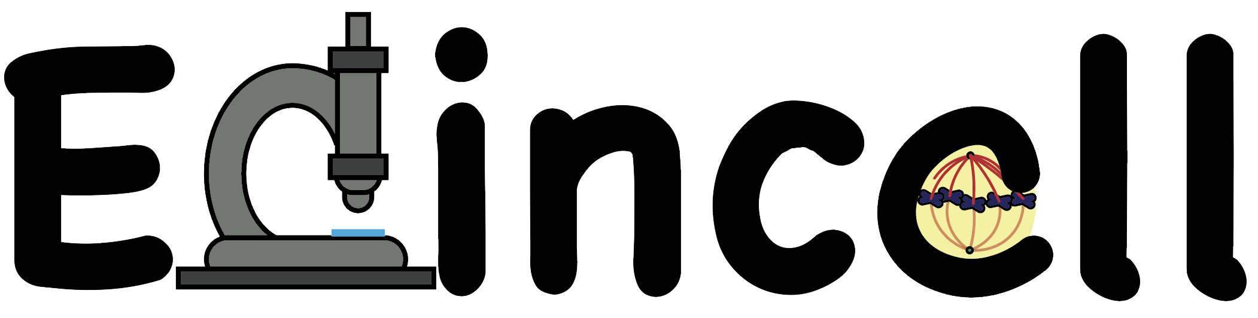
“BUILD YOUR OWN FLY”
MEIOSIS AND THE GENERATION OF GENETIC DIVERSITY.
- This card game is a good way to illustrate the concept of inheritance.
- The children will learn what is genetic diversity (i.e. why do we all look different to each other) and how it is generated.
- The activity has been tested successfully in the classroom and Science Festivals for children from P3.
What we are going to learn:
- Why do we look a bit like our mum and dad? Concepts of inheritance and genes:
  - Our genes determine how we look like.
  - We get half our genes from mum and half from dad.
- Why do we look a bit different from our parents/brothers/sisters?
  - We each get a different combination of genes from our parents:
  - Genes get shuffled (like cards in a deck) so brothers/sisters get slightly different combinations of genes. THAT MAKES EVERY ONE OF US UNIQUE.

- THE WORKSHOP: MAKE YOUR OWN FRUIT FLY.
The game for the classroom is based on the Genetics of fruit flies (Drosophila melanogaster), a widely used model organism in biomedical research.
Genes are contained in chromosomes inside the cell. Fruit flies have only four pairs of chromosomes (as opposed to 23 pairs in humans). So it is a much simpler system to use to explain inheritance.
Each card represents a chromosome (paternal chromosomes printed in blue card, maternal chromosomes in purple card).
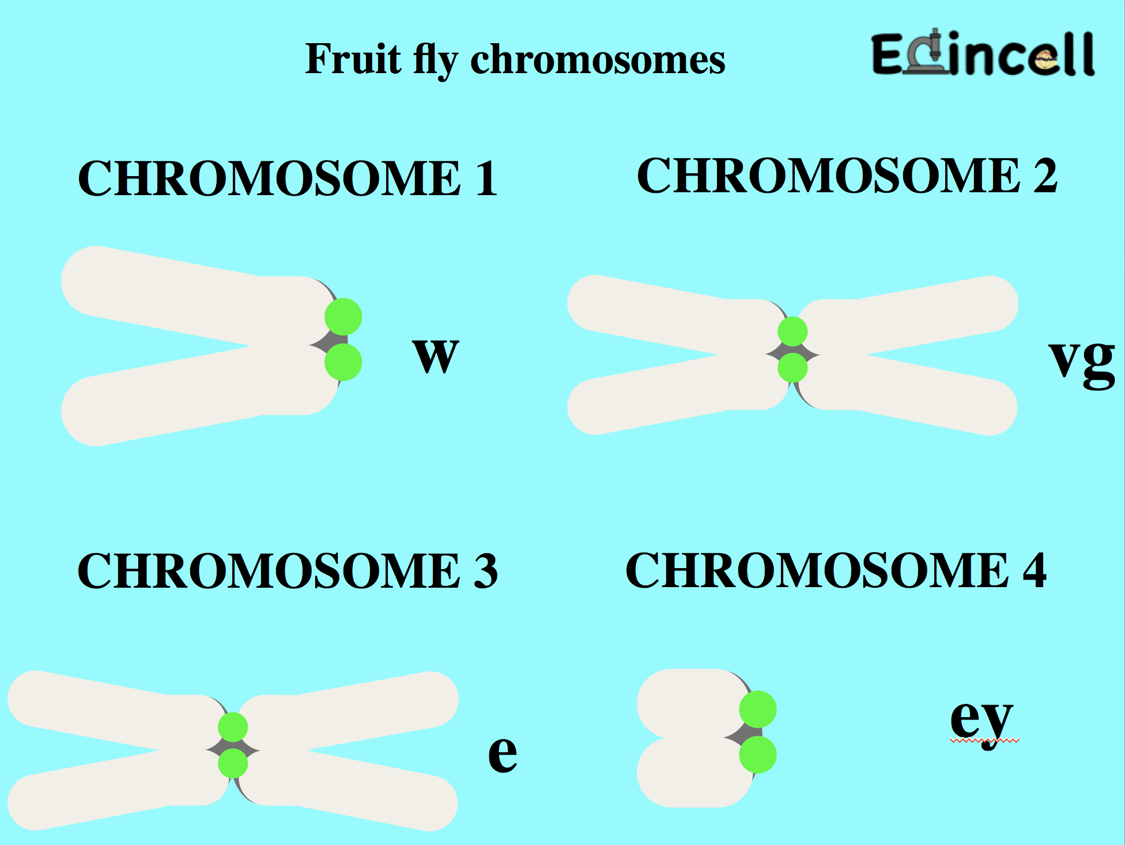

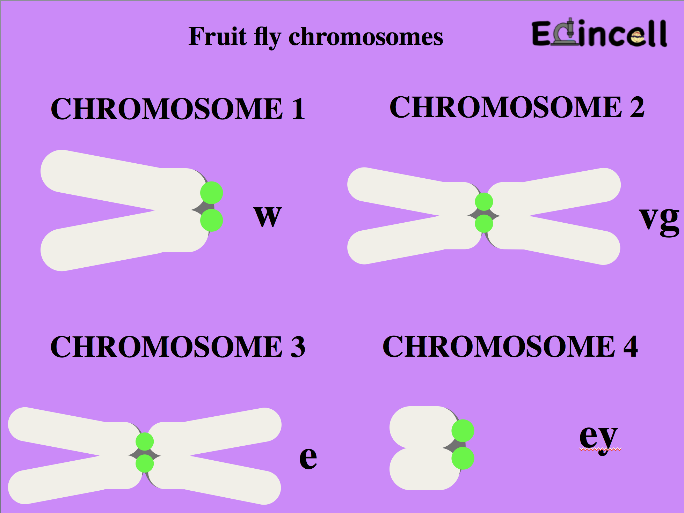

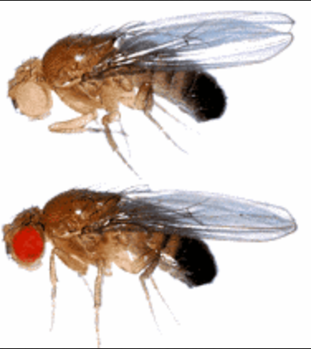
Chromosomes contain the genes that will determine how the fly will look like (phenotype). Each card (chromosome) carries either a “normal”-or “most common”- copy (noted by +) or a mutant copy of a gene (noted by the gene name abbreviation).
Mutant
EXAMPLE:
Most fruit flies have red eyes (+) but some mutants have white eyes:
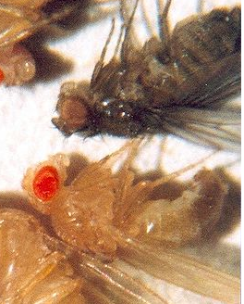
Mutant
Most fruit flies have yellow bodies (+) but some mutants have dark bodies

1 – Each child (or team) will receive four pink “chromosome cards” (X, 2, 3 and 4) from the mother fly and four blue cards from dad fly.
2 – They will arrange the chromosomes in pairs (X-X, 2-2, 3-3, 4-4).
3.- They will “decipher the genetic code” according to the table provided by the teacher.
Combinations (table):
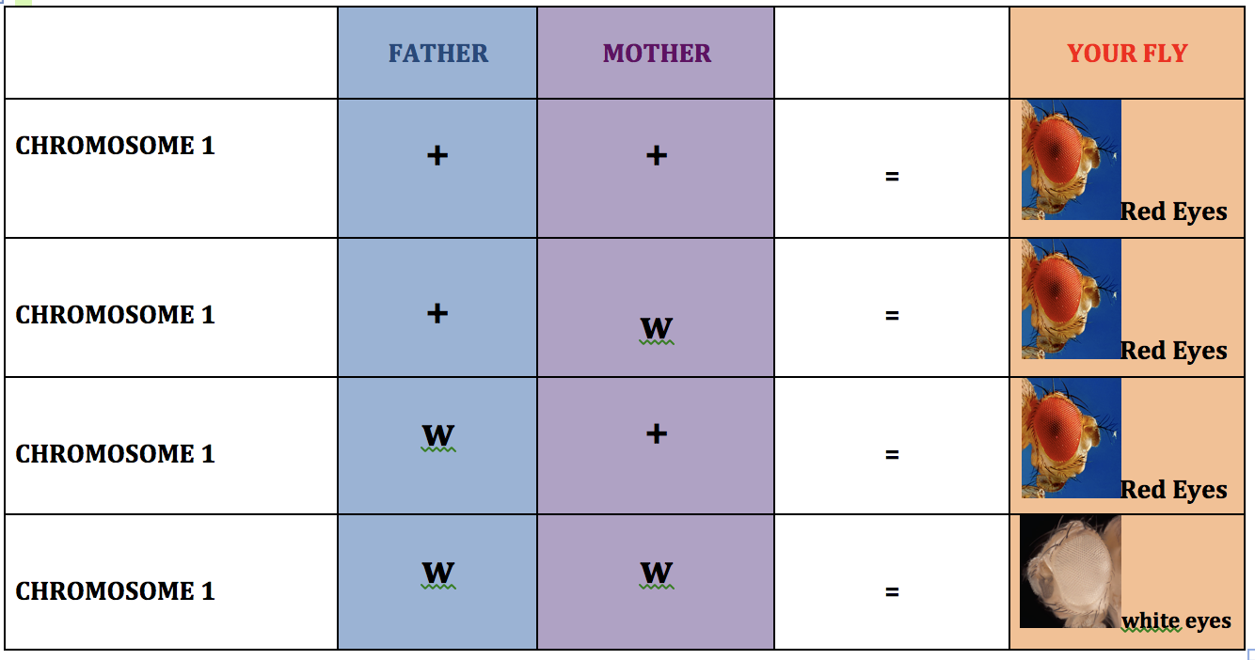

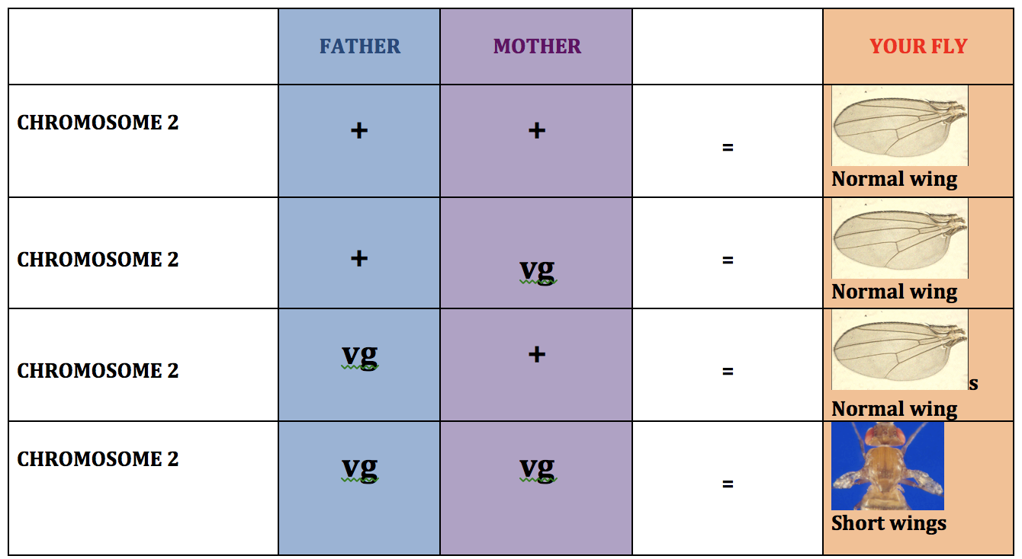

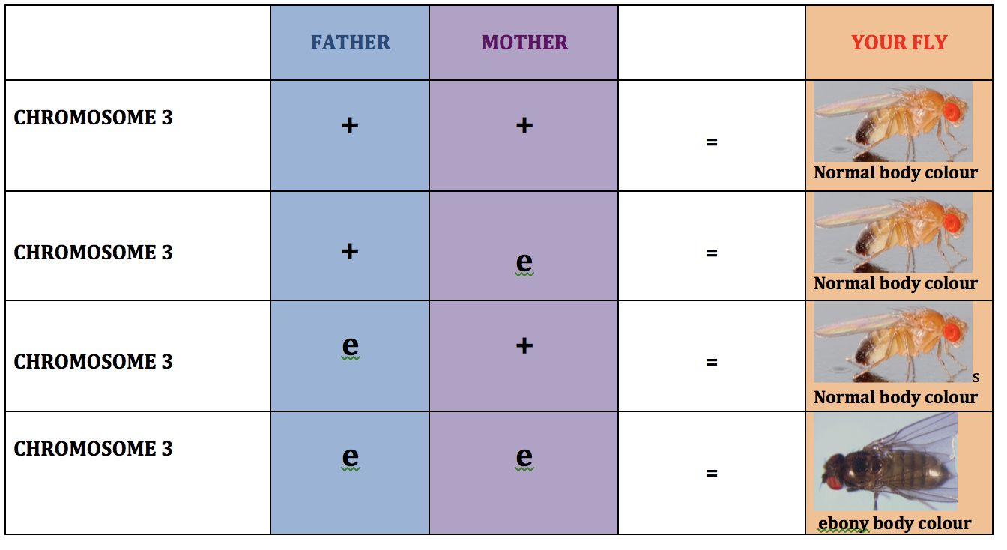

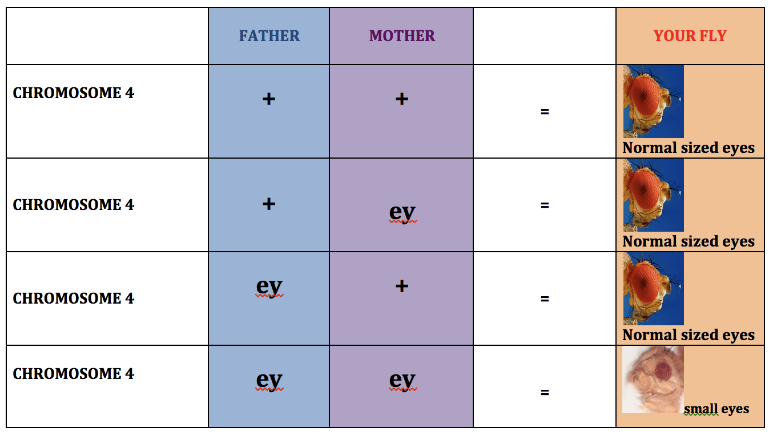

4.- The children will write down on the table what their fly will look like:
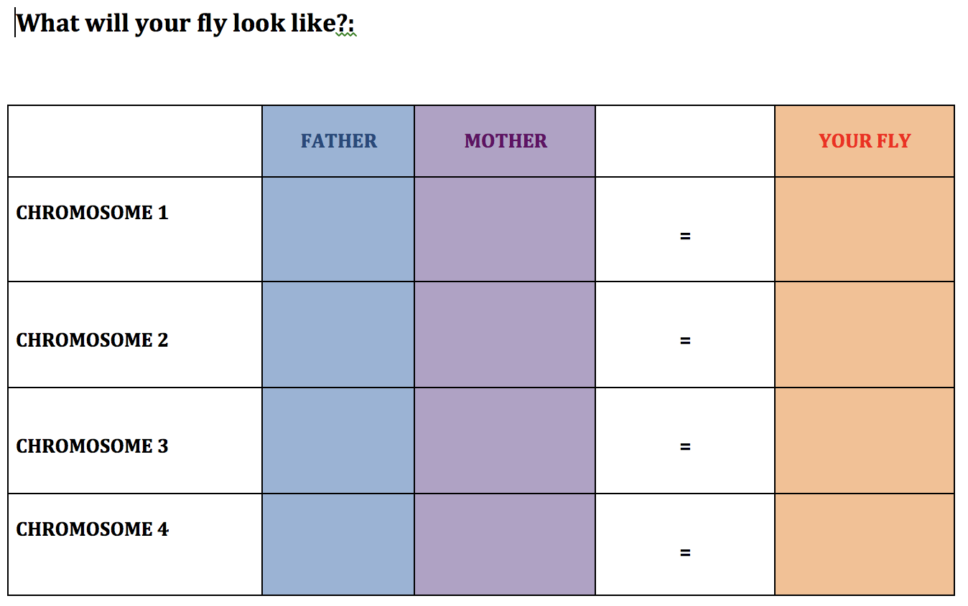

And build their fly accordingly:

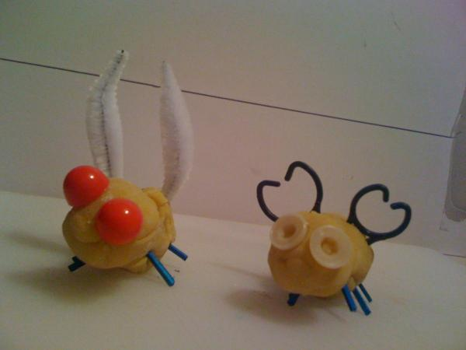

5.- All the flies can then be displayed together. There will be lots of different-looking flies, coming from the same mum and dad. Discuss: Generation of genetic diversity.

6.- For older children, the teacher can introduce the concepts of natural selection and evolution.
Example: vg (vestigial mutant, small wings) flies have shorter wings, they are much worse at flying/moving and they will be easier prey for birds. Flies with normal wings will have a better opportunity to survive and have baby flies (so their genes will be selected and will be more abundant in the next generations).

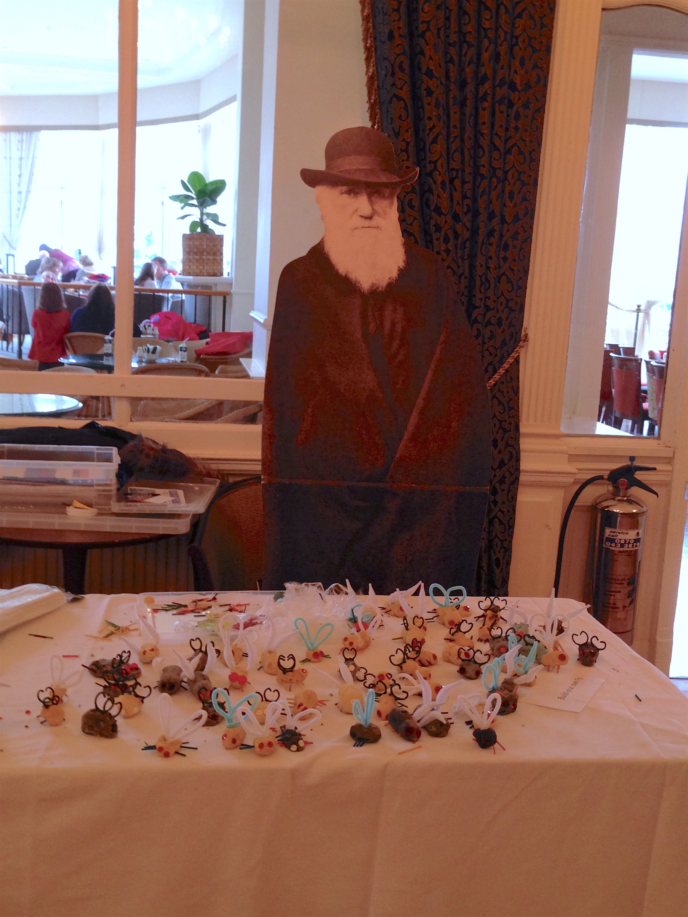

BENCHMARKS: Suggested links

EARLY LEVEL:

Inquiry and investigative skills

- Explores and observes through play.
- Asks questions arising from play activities.
- Makes simple predictions of what might happen.
- Makes suggestions about what to do to answer the selected question.

FIRST LEVEL:

Curriculum Organisers:
Inheritance

Experiences and Outcomes for planning learning, teaching and assessment:
By comparing generations of families of humans, plants and animals, I can begin to understand how characteristics are inherited.

Benchmarks to support practitioners’ professional judgement:

- Uses their own experiences to illustrate how inherited characteristics are passed from one generation to the next.
- Knows that genetic information determines characteristics such as colour of eyes and shape of petals.
- Demonstrates understanding of the variations within family groups.

SECOND LEVEL

Curriculum Organisers:
Inheritance

Experiences and Outcomes for planning learning, teaching and assessment:

- By exploring the characteristics offspring inherit when living things reproduce, I can distinguish between inherited and non-inherited characteristics.

Benchmarks to support practitioners’ professional judgement:

- Knows that genetics is the study of inherited characteristics and that inherited characteristics are carried on genes and can sometime skip a generation.
- Explores and categorises characteristics into inherited (eye and hair colour, height and right/left handedness) and non-inherited (native language spoken and favourite colour).
- Describes how every living thing has its own DNA fingerprint.

