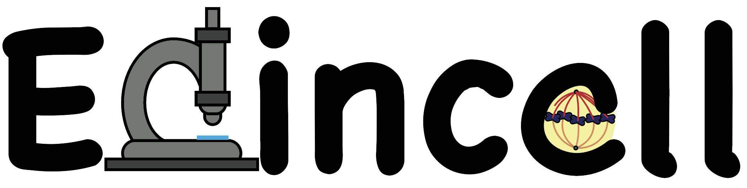

INHERITANCE:
DNA, GENES and MUTATIONS.

- One of our most popular workshops, introduces Primary School children to the biology of DNA and genes.
- We have carried out this workshop in the classroom (P4-P5). It can be adapted for older children.
What we are going to learn:
- What is DNA?
  - DNA is a chemical that contains all the information required to make you! We are all different because we have our own different DNA.

  - DNA (DeoxyriboNucleic Acid). It is made up of four different “blocks” (A-T-G-C) called bases.

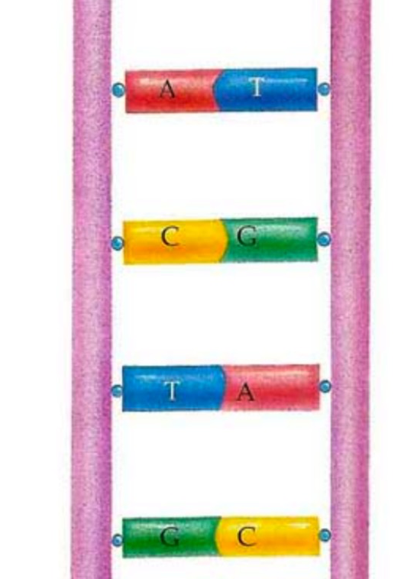
  - The shape of DNA is like a ladder. Each step of the ladder is formed by two bases.

  - The bases are shaped to fit each other like the pieces in a jigsaw puzzle:
    - A always fits T.
    - G always fits C.

  - The information is contained in the order of the bases (sequence). This is called the genetic code. There are around 3 billion bases in one of your DNA molecules.

- Where do we find DNA?
  - In every cell of your body (except red blood cells).

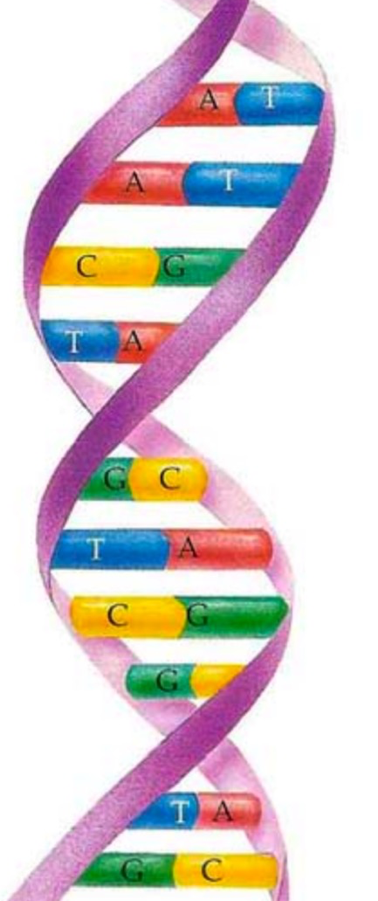
- How does it look like?

  - The DNA ladder twists
to form a double helix!

- What is a mutation?
  - A mutation is a change in your DNA. Sometimes mutations make the information of the DNA change.

- THE WORKSHOP: SWEET DNA.
1.- Introduction to DNA: one of our staff (or the class teacher) gives a very brief introductory talk to the activity. The children learn about the genetic code and how the base pairs are required to build the double helix.

2.- Make your own DNA: the children receive a bag containing all the ingredients to make their own DNA molecule out of sweets.

Example: - 1-2 liquorice wheels (helices); cocktail sticks to make the steps of the ladder; jelly beans of 4 different colours representing the chemical bases (A-T-G-C); mini marshmallows (phosphate groups); a sweet pencil to hold the structure.

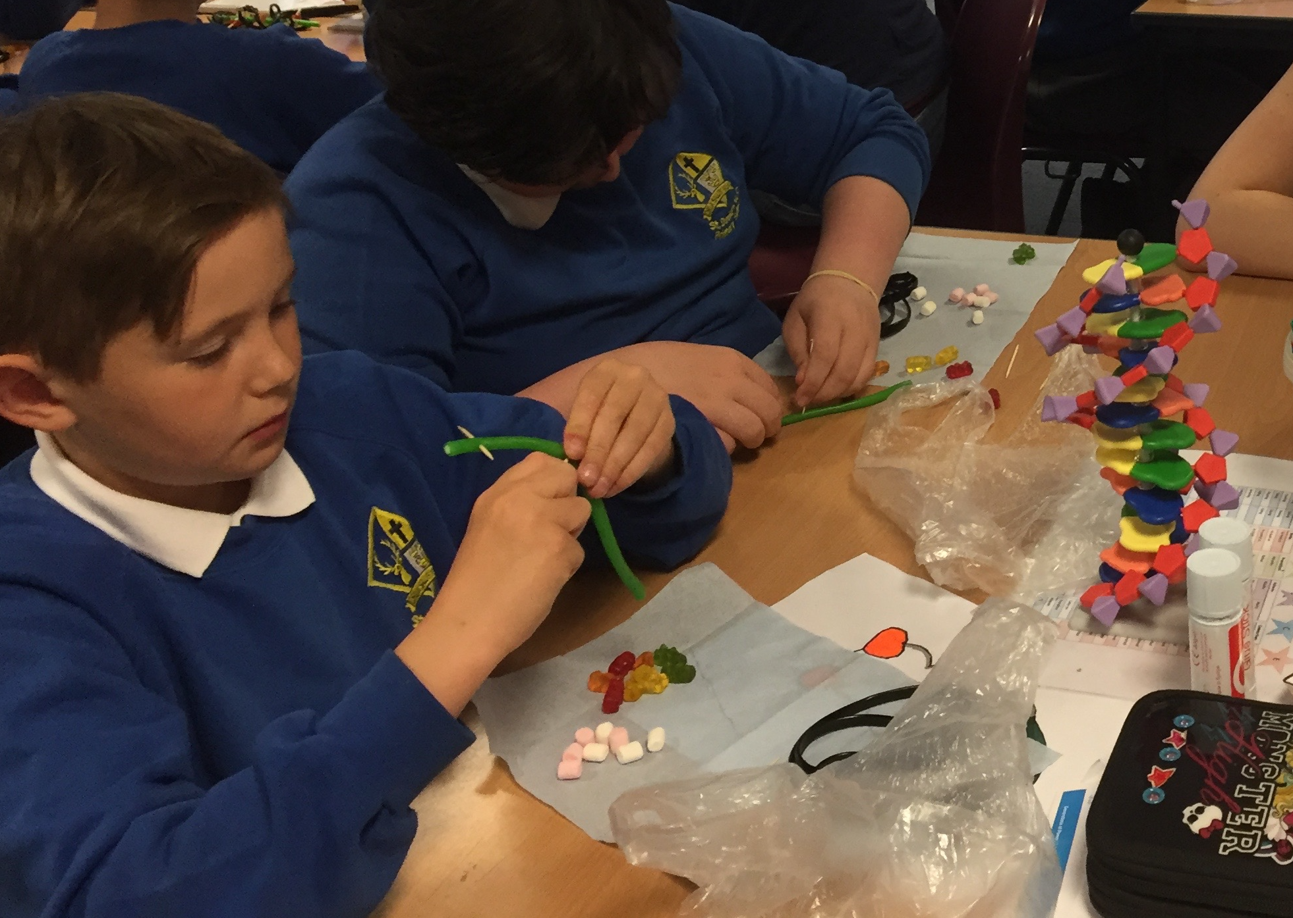
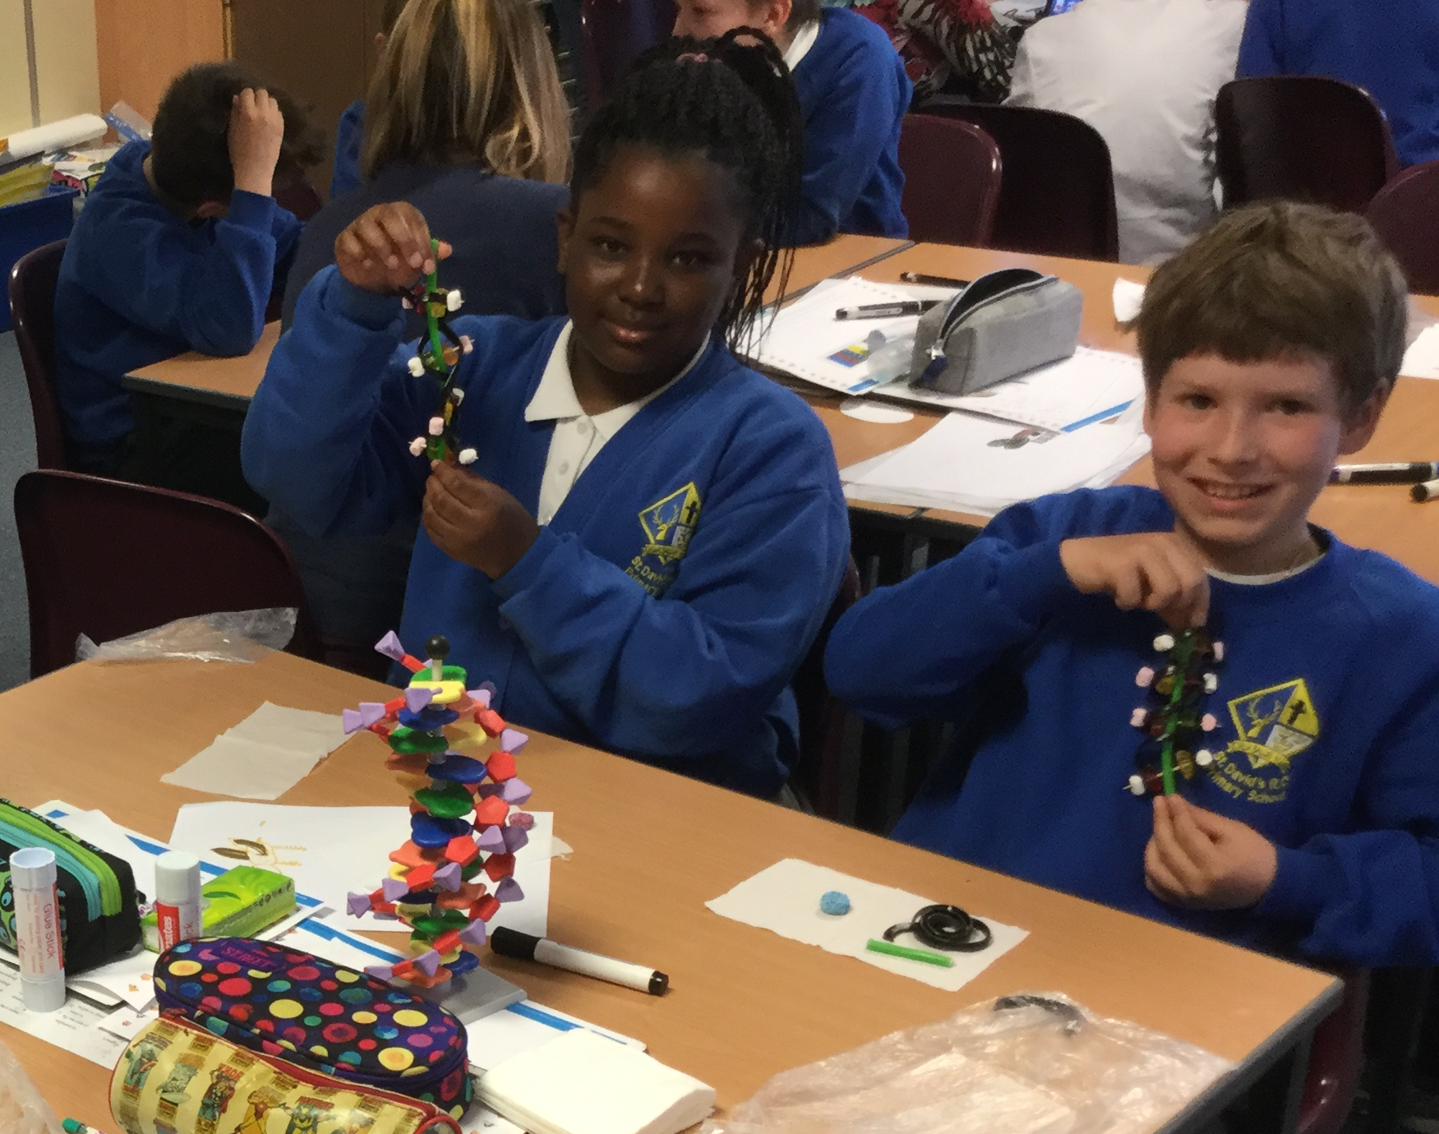

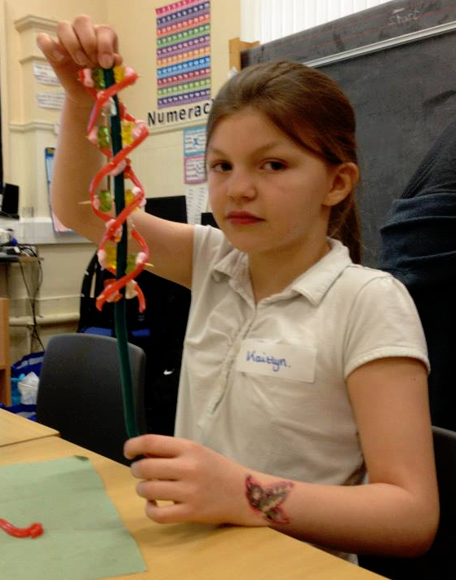
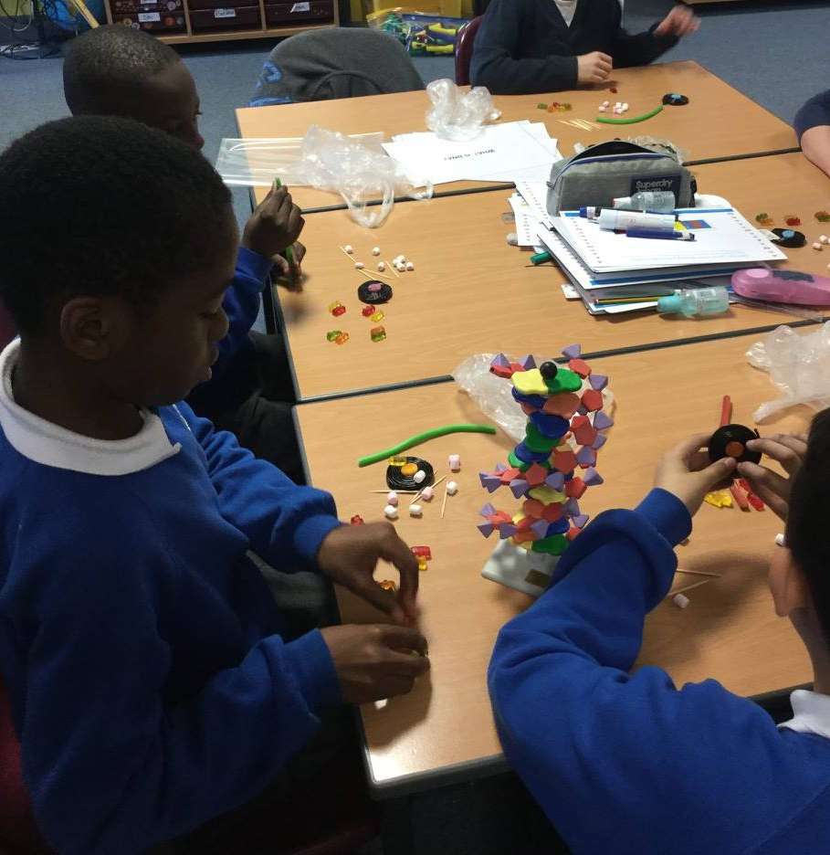

BENCHMARKS: Suggested links

EARLY LEVEL:

Inquiry and investigative skills

- Explores and observes through play.
- Asks questions arising from play activities.
- Makes simple predictions of what might happen.
- Makes suggestions about what to do to answer the selected question.

FIRST LEVEL:

Curriculum Organisers:
Inheritance

Experiences and Outcomes for planning learning, teaching and assessment:
By comparing generations of families of humans, plants and animals, I can begin to understand how characteristics are inherited.

Benchmarks to support practitioners’ professional judgement:

- Uses their own experiences to illustrate how inherited characteristics are passed from one generation to the next.
- Knows that genetic information determines characteristics such as colour of eyes and shape of petals.
- Demonstrates understanding of the variations within family groups.
SECOND LEVEL

Curriculum Organisers:
Inheritance

Experiences and Outcomes for planning learning, teaching and assessment:

- By exploring the characteristics offspring inherit when living things reproduce, I can distinguish between inherited and non-inherited characteristics.

Benchmarks to support practitioners’ professional judgement:

- Knows that genetics is the study of inherited characteristics and that inherited characteristics are carried on genes and can sometime skip a generation.
- Explores and categorises characteristics into inherited (eye and hair colour, height and right/left handedness) and non-inherited (native language spoken and favourite colour).
- Describes how every living thing has its own DNA fingerprint.

